Malcolm Clemens Young Job 19:21-27a
Grace Cathedral, San Francisco, CA 2C49 Canticle 9
All Souls Requiem (Mozart) 11:00 a.m. Eucharist Luke 24:13-35
Sunday 13 November 2022

The Invisible Beauty
“Then their eyes were opened and they recognized him” (Lk. 24).

Forms of beauty exist that we are only dimly aware of. So much happens that we fail to notice. We never experience some of the most beautiful phenomena in nature.

Have you ever been in the Pacific Ocean and seen the sun rise over the continent? The light creates a brilliant golden path over the water that seems to go right to you. Under certain conditions, when you are far out beyond the impact zone, air gets trapped in large exploding waves creating a brilliant, short-lived shower of spray and a rainbow.

When you really know the water, the texture of the ocean surface reveals currents and eddies that help you to find safety. And on a few days in your lifetime the gray of the sky will perfectly match the gray of the water and the rain will fall in such a way that it seems like a million drops of water are frozen midair just above the surface.

Surfing on certain fall days at Ocean Beach the wind blows offshore, the wave doubles up and pitches over your head so that you are encased in smooth walls of emerald green. As the wave collapses behind you spray engulfs you and you are spit out back into the regular world again. I wish so dearly that I could communicate what it feels like to be riding a wave and see a dolphin just below the surface doing the same thing.

Because of grief the disciples fail to see the most beautiful thing of all. They fail to see God in the presence of their friend Jesus. Today I especially understand this feeling. Mike Lawler was one of my dearest friends, the one who helped me to see all of what I just described, the generous soul who taught me to surf. Two days ago I learned that he died. At surprising times I keep finding myself emotionally overwhelmed.

Mike was a six foot five inch, 220 pound contrarian bull and the world was his China shop. He dropped out of college to pioneer surfing on the Northshore of Oahu. He was not shy about confronting over-educated people who were full of hot air. He was a literary roofing contractor. He said, “I used to write sermons when I was shingling roofs, alone with my thoughts and the rhythm of a hatchet whacking nails into cedar shakes.”

We spent hundreds of hours together driving to the beach in his pickup truck. It smelled strongly of wetsuit neoprene, surf wax, and cigar that he later told me he smoked so that his car didn’t smell like marijuana. We talked about creativity, painting, science, Martin Heidegger, Werner Erhard and the sixties. He taught me about the culture, art, physics, meteorology, history, ethics, sociology and technique of surfing. He introduced me to the pleasure of old-fashioned donuts and that is what I crave now after every surf session.

Each All Souls Requiem at Grace Cathedral feels so different, because nothing seems more particular, more specific than the loss of someone we love. And each year that loss feels different.

Today we carry with us the joy of being together after the pandemic but also the weight of so many funerals we have been hosting this fall to honor the many people who died over the last three years. We have had so many more losses as a community I hesitate to even name anyone. Who can imagine life here after Dare’s death last week?

On Wednesday Chris Keady and I talked about the feeling of Mozart’s requiem. Mozart (1756-1791) composed this as he himself was dying and the music conveys a sense of frustration and anger at our limits as human beings. It expresses anxiety about whether we will be forgiven for the damage that we have done. Mozart is not afraid to encourage us to face our sadness. And with the tension and disappointment we also encounter what is beautiful, what we have not yet noticed.

The theologian David Bentley Hart writes that, “what is most mysterious and exalted is also that which, strangely enough, turns out to be most ordinary and nearest to hand, and that which is most glorious in its transcendence is also that which is humblest in its wonderful immediacy… we know far more than we are usually aware of knowing…”

The modern twentieth century French composer Olivier Messiaen (1908-1992) spent nine months in a World War II German prisoner of war camp composing “Quartet for the End of Time.” It uses the four musical instruments that were available there (Piano, Cello, Violin, Clarinet). He saw such suffering and had every reason to surrender to cynicism. But instead he was fond of paraphrasing Thomas Aquinas (1224-1274) reminding us that, “God dazzles us by an excess of truth.” He writes, “Certain people are annoyed that I believe in God. But I want people to know that God is present in everything, in the concert hall, in the ocean, on a mountain, even on the underground.”

The ancient theologian St. Gregory of Nyssa (335-339) believed that death and evil ultimately cannot hinder us in moving toward God. Hart summarizes his theology writing, “Creation is… a partaking in the inexhaustible goodness of God; and its ceaseless flow of light and shadow, constancy and change… while the restless soul, immersed in the spectacle of God’s glory, is drawn without break beyond the world to the source of its beauty, to embrace the infinite.”

My tough, impermeable, sometimes obnoxious surfing friend Mike Lawler believed this. He was so proud of being a lifelong Episcopalian. The disciples walked many miles without recognizing Jesus and I did the same when I walked with Mike.

A few years ago he wrote a December letter to me from his home in Hawaii about his own death. He said death used to seem so far off “to be no bother.” And then he quotes Joan Didion whom he describes as an Episcopalian (from her book The Year of Magical Thinking).

Didion writes, "We are not idealized wild beings. We are imperfect mortal beings, aware of that mortality even as we push it away, failed by our very complication, so wired that when we mourn our losses we are mourning, for better or worse, ourselves. As we were we are no longer. As we will one day be not at all… as it was in the beginning is now and ever shall be."

Mike closes his letter with these words, “My life has been partly molded by having lost a little sister when I was about thirteen. You are afraid to love [because those you] love will die. I wish there was a way to get over the fear… but this is not a conversation for Advent… The ocean was calm and glassy tonight as the spangled sun made you look and love the world. Your sermon touched me as no other. Love, Mike.”

Forms of beauty exist that we are only dimly aware of. We are drawn beyond the world to the source of its beauty.
__________
Images:
Lindamar at sunrise
Mike Lawler and Malcolm
David Bentley Hart
Wolfgang Amadeus Mozart
Joan Didion
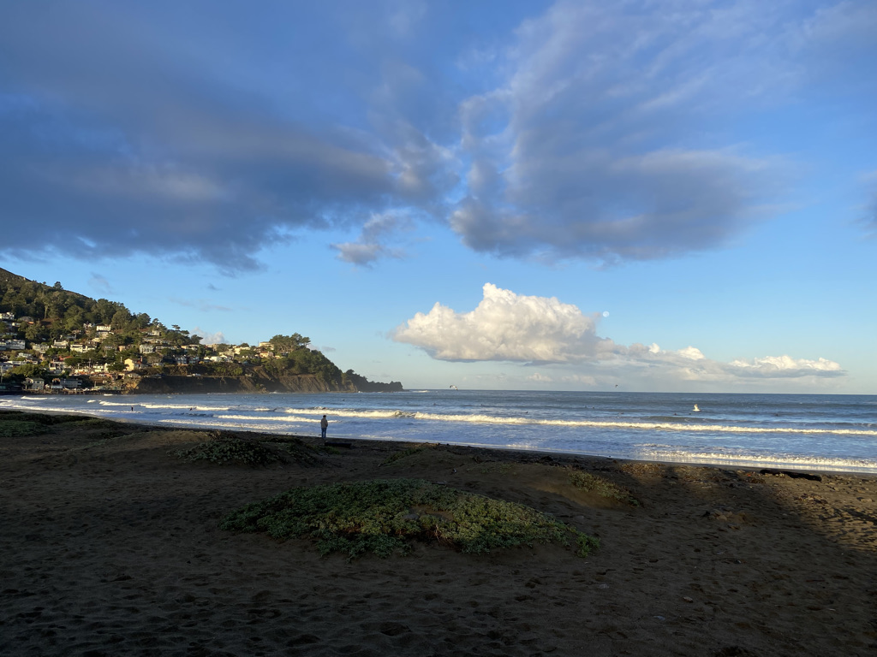
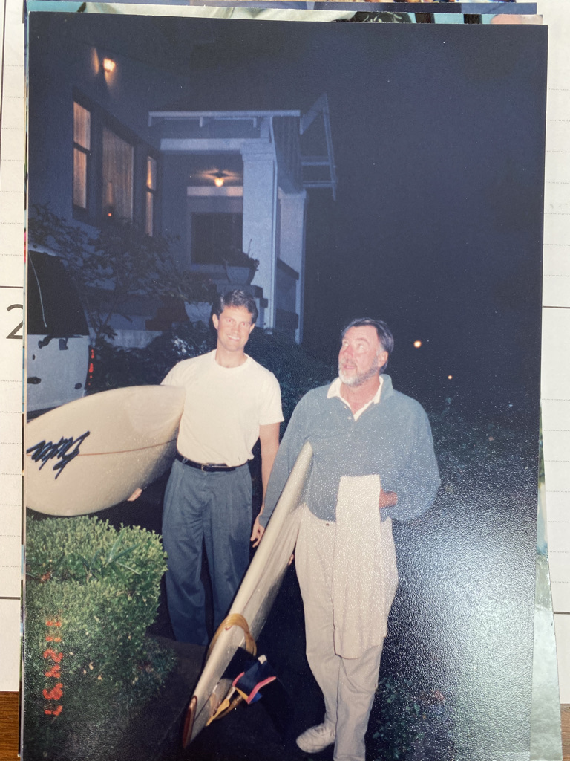

On Dec 9, 2017, at 6:34 PM, Mike Lawler <palmistartist@gmail.com> wrote: Dear Malcolm, I used to write sermons when I was shingling roofs, alone with my thoughts and the rhythm of a hatchet whacking nails into cedar shakes. I was the sinner I preached against. I used to hear some good ones, Fr Bowden an ex Congregationalist from Boston railing against nuclear bombs, ala that English pacifist, Bertrand Russell, "Dis arm. Dis arm." I thought he was nuts. He drove an ancient Mercedes Benz. I wondered how he ended up in Los Angeles. He reminded you of the fat English director Alfred Hitchcock. The people liked him as I remember…. Happy Sunday, Love Mike
This season I preached funeral sermons for: Marcia McCowin, Bill Gaede, Joan Silva, Everett Davis, Eric Hubert, David Forbes, John Lynch, Jenny Berlecamp, Aubrey Bartlett.
David Bentley Hart, The Experience of God: Being, Consciousness, Bliss (New Haven: Yale University Press, 2013) 84.
Alex Ross, The Rest Is Noise: Listening to the Twentieth Century (NY: Farrar, Strauss, Giroux, 2007) 471-2.
David Bentley Hart, The Beauty of the Infinite: The Aesthetics of Christian Truth (Grand Rapids, MI: Eerdman’s, 2003) 194-5.
On Dec 8, 2017, at 9:26 PM, Mike Lawler <palmistartist@gmail.com> wrote: Dear Friend, Sermon: Episcopalian Joan Didion's The Year of Magical Thinking. Death, it seemed so far off as to be no bother, but now at 75, Crap! She quotes Gerard Manly Hopkins,( Margaret are you grieving/over golden grove unleaving? and, It is the blight man was born for,/It is Margaret you mourn for. She goes on, It is the blight man was born for. "We are not idealized wild beings. We are imperfect mortal beings, aware of that mortality even as we push it away, failed by our very complication, so wired that when we mourn our losses we are mourning, for better or worse, ourselves. As we were we are no longer. As we will one day be not at all.") She writes, "as it was in the beginning is now and ever shall be." My life has been partly moulded by having lost a little sister when I was about thirteen. You are afraid to love. Whom you love will die. I wish there was a way to get over the fear. It's a dread I have always felt for my children. This is not a conversation for advent. Good Friday maybe. Your most recent remained on the side of the living; "glad it wasn't me." The truth is it will be you, and every beating heart in your congregation. There is a punch line in a joke I can't recall, "Your time is up." Actually there is an Advent component, "Get ready." The ocean was calm and glassy tonight as the spangled sun made you look and love the world. Your sermon touched me as no other. Love, Mike On Fri, Dec 8, 2017 at 2:03 PM, Malcolm Young <malcolmy@gracecathedral.org> wrote: Dear Mike, Thanks so much for this. I think of you so often and am glad to hear from you. On Wednesday I was locked in on a beautiful right. I made the first section and then out of nowhere there was a board right in front of me. I popped over it but it put two gouges in the bottom and knocked out the skeg. I was putting in the new fins this afternoon and thinking of you… Love, Malcolm On Dec 8, 2017, at 12:07 PM, Mike Lawler <palmistartist@gmail.com> wrote: Hard to let go of ego. Listening to your 12/3 [1 Advent (12-3-17) B]sermon, like me, the congregation must surely have failed to keep dry eyes. At West Hollywood Baptist church sitting in plush theater seats with a girl friend whose father was a deacon, there was what I learned later, an altar call. Fearful, I asked her if he was talking to me. "No," she said. "He always says that." On Sunday, you were talking to me. Mahalo nui, Love Mike

