Malcolm Clemens Young Genesis 18:20-32
Grace Cathedral, San Francisco 2C24 Psalm 85
7 Pentecost (Proper 12C) 8:30 a.m. and 11:00 a.m. Eucharist Colossians 2:6-15 (16-19)
Sunday 24 July 2022 Luke 11:1-3

Bread at Midnight: Cathedral Tour Homecoming
“Ask, and it will be given you; search, and you will find; knock and the door will be opened to you” (Lk. 11).

The Holy Spirit is here. An urban legend has it that when David Cameron, the former Prime Minister of the United Kingdom packed up his office he left three envelopes for his successor Theresa May with a note saying, “Open one of these when you get into trouble.”

When negotiations with the European Union over Brexit started she opened the first envelope. It said, “Blame your predecessor.” Later when she lost the first Brexit vote she opened the second envelope which read, “Reshuffle your cabinet.” Finally, after she lost the third vote on her Brexit plan she opened the final envelope. It said, “Prepare three envelopes.”

This story comes from Sam Wells the Vicar of St. Martin in the Fields. We met with him in London early in our journey this summer. He says there are two primary anxieties in our time, that can be simply expressed by two questions: First, is the universe simply meaningless and accidental, merely dead matter decomposing according to the principle of entropy into isolation and coldness? Second, will I be okay? In the face of this situation Jesus presents us with three far more helpful envelopes for us to open when things go wrong.

I want to talk about these instructions in the context of our Cathedral Tour journey. As we move into the next phase of the pandemic this is a crucial moment in the history of Christianity. Over the winter 31 trustees attended dinners I arranged to talk about how Grace Cathedral can lead and serve in this context. This week my wife Heidi and I returned from visiting over fifty churches in England and France where me met with church leaders to talk about what they see. We took 80 pages of notes, recorded twenty-five video interviews, posted dozens of pictures on social media – I have not yet fully assimilated what we saw or learned but I want to share this experience with you today.

1. Repentance. When Jesus returns to his friends after being away in prayer, they seem anxious and they ask him to teach them to pray. Jesus gives them what we call the Lord’s Prayer, the Our Father. You can carry this around in your heart and when you need help, it gives you a place to begin.

This week I especially noticed how the way we say this prayer differs from the words in this gospel. We pray, “forgive us our sins as we forgive those who sin against us.” But this translation of the Bible says, “Forgive us our sins, for we ourselves forgive everyone indebted to us” (Lk. 11). Preachers often make a big deal about the conditional nature of this instruction – if we do this, then God will do something for us. But this morning what strikes me most is that people who love God will naturally want to be forgiving. The struggle over forgiveness and repentance lies at the heart of the spiritual life. A mature believer knows that as we want justice for ourselves, others desire this too.

This leads me to a difficult subject that I need to address. It was very hard for me to leave and to go on this cathedral tour because of tensions here at home in our own community. This is embarrassing for me to talk about, but not long before departing I and many others learned that some Executive Committee trustees were very disappointed in my leadership.

After the pandemic we never resumed meeting in person and what I have to repent for is my role in not doing a better job of communicating and staying connected to them. COVID twists, distorts and confuses so much. It kills relationships as well as people.

One of my most cherished moments of the summer came when we visited the cathedral nearest to our former dean Alan Jones’ childhood home. I kept wondering what Winchester taught him about how to be a dean here 5,000 miles away. A docent named Matt Winter took us on an alarming tour that began with graphic evidence of an ongoing and serious flooding problem in the crypt. He showed us how the very walls of the apse had begun to buckle in the late 1800’s.

Then he talked about the hero who saved the cathedral. A diver named William Wallace rode the train from his home in Croyden every day (on occasion he biked home, but that is another story). At first he had a partner, but that person had to quit because the work was too terrifying. Wallace was a diver in one of those old fashioned suits with the metal fishbowl helmets. His helper had to continuously pump air for him as he went into the dark murky water beneath the massive and collapsing cathedral walls in order to carefully place heavy bags of concrete which then hardened in place. For eight hours a day over five and a half years he did this.

Repentance and forgiveness can be like this – terrifying, difficult and demanding, but this is how a cathedral is really built.

2. Persistence. Jesus tells about a man knocking on his neighbor’s door at midnight. The neighbor will give him bread not out of generosity but because he wants to be left alone. It’s a strange image that Jesus uses to encourage us to be persistent in seeking God.

In his book on St. Augustine, Rowan Williams the former Archbishop of Canterbury writes about memory and time. When we sing a song from memory, the whole song is not available to us at once, just the part of it that we are singing at that moment. In a sense the end and the beginning of the song are with us but not in our immediate consciousness. It’s like that feeling we have when we are trying to think of a word or name. We say, “it will come to me in a minute.” This gives us a picture of who we are.
In a sense we are our memories and yet our memories are not totally available to us. This is how we experience our self and God. The whole is never completely present to us. Our memories and their meaning are shifting according to the stories we tell. Church gives us the chance to recalibrate, so that our stories again harmonize with the truth. That is a central reason we need to persist in worship.

One of my favorite conversations this summer was with Sub-Dean Richard Peters at Christ Church Cathedral in Oxford. A week ago after spending four hours with us (drinking sherry in the garden, touring and evensong) he said what he had just inadvertently demonstrated, “Hospitality is fundamental to the Christian life.” This generosity of spirit comes from someone who has been and is constantly not welcomed by the church because for thirty-five years he has loved his life partner Nicholas who happens to be another man.

Richard went on. He said, “Prayer is not that difficult.” We struggle with it, but really it is simply talking to God. This is what allows us to receive the gifts of wonder and awe that are one way that we enjoy God and take delight in God.

3. God’s love. The final envelope that Jesus leaves us is his description of God’s love. How we love our children is an analogy for how God loves us. We know how to give good gifts and God does too. The most important thing I want to share with you today is this. What God is giving us is enough, because what we receive is the Holy Spirit.

One of the best of summer was time with our twenty-one year old daughter Melia. We were not together. I would do anything to please her. We wandered through thrift shops on Brick Lane, small shops in Notting Hill, outdoor markets and the Sky Garden.

We said goodbye sitting at a picnic table in a small Bloomsbury park at dusk. Because I will not be helping her to move into college this year, we don’t know when we will see each other again. Deep feelings like this help us to understand God’s love for us. As we walked away into the night I felt an enormous sense of gratitude for my wife Heidi. She is not just the Executive Producer of our films but a delightful, bright companion through every moment of the summer.

The day after David Ison retired as dean of St. Paul’s Cathedral, London, he took us on a behind the scenes tour. At the very end he talked about hearing a confession that upset him so much that he went to pray in a small crypt chapel. Although he had already been dean for years, he discovered something new about his cathedral.

Behind the memorials for Horatio Nelson and the Duke of Wellington there is a small grave for the first modern professional dean of St. Paul’s. Before his time deans might collect a salary from, but not often visit, their own cathedrals. Dean Millman though was a poet and an Oxford University professor who loved his cathedral ministry.

Around his coffin an inscription lists the books he wrote and the nineteen years he served. But a larger inscription encompasses his grave and another. It says, ““IN PIOUS MEMORY OF MARY ANNE THE BELOVED WIFE OF HENRY HART MILLMAN SOMETIME DEAN OF THIS CATHEDRAL CHURCH. BENEATH THIS STONE RESTs IN ONE GRAVE WITH HIM FOR WHOM SHE MADE THE POETRY OF LIFE REALITY.”

My friends, I missed you so much this summer. What a blessing it is to be home with you again and to hear the words of Jesus together. We inhabit a world in agony, struggling over anxiety that can be expressed in two questions: “Is this a dead universe? Will I be okay?” But Jesus does not leave us unprepared. Jesus shows us how to pray.

Although we cannot fully know ourselves or God, let us continue to keep repentance and forgiveness at the heart of our shared life. Let us be known for our persistence in seeking God and in offering hospitality. And finally let us not forget that what God is giving us, is enough. The Holy Spirit is here.

Images:
Prime Minister Theresa May (not supplied)
Diving Helmet Monument (below)?
William Wallace building Winchester Cathedral drawing (below)
Richard Peers (w/Heidi, me and Nicholas below)
St. Paul’s Cathedral, London (below)
Heidi/Melia (below)
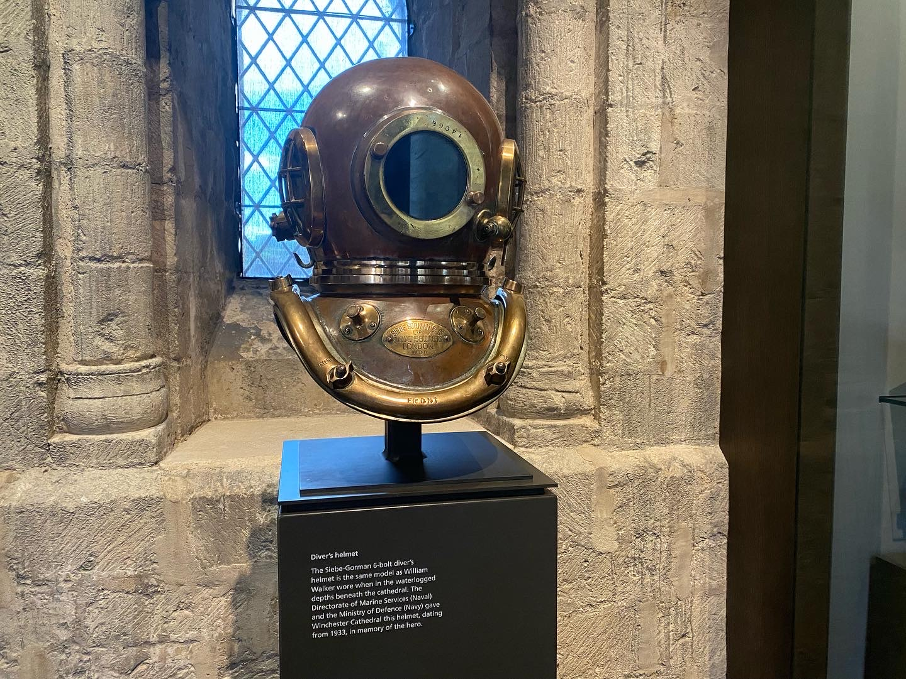
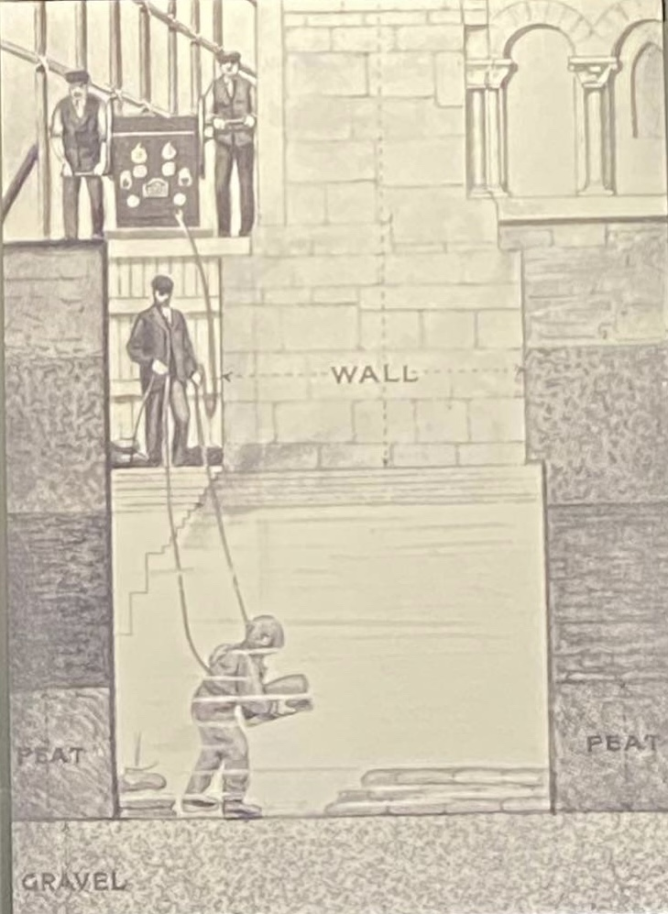
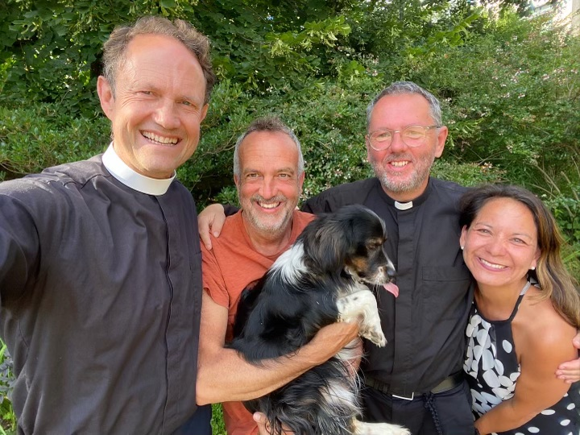
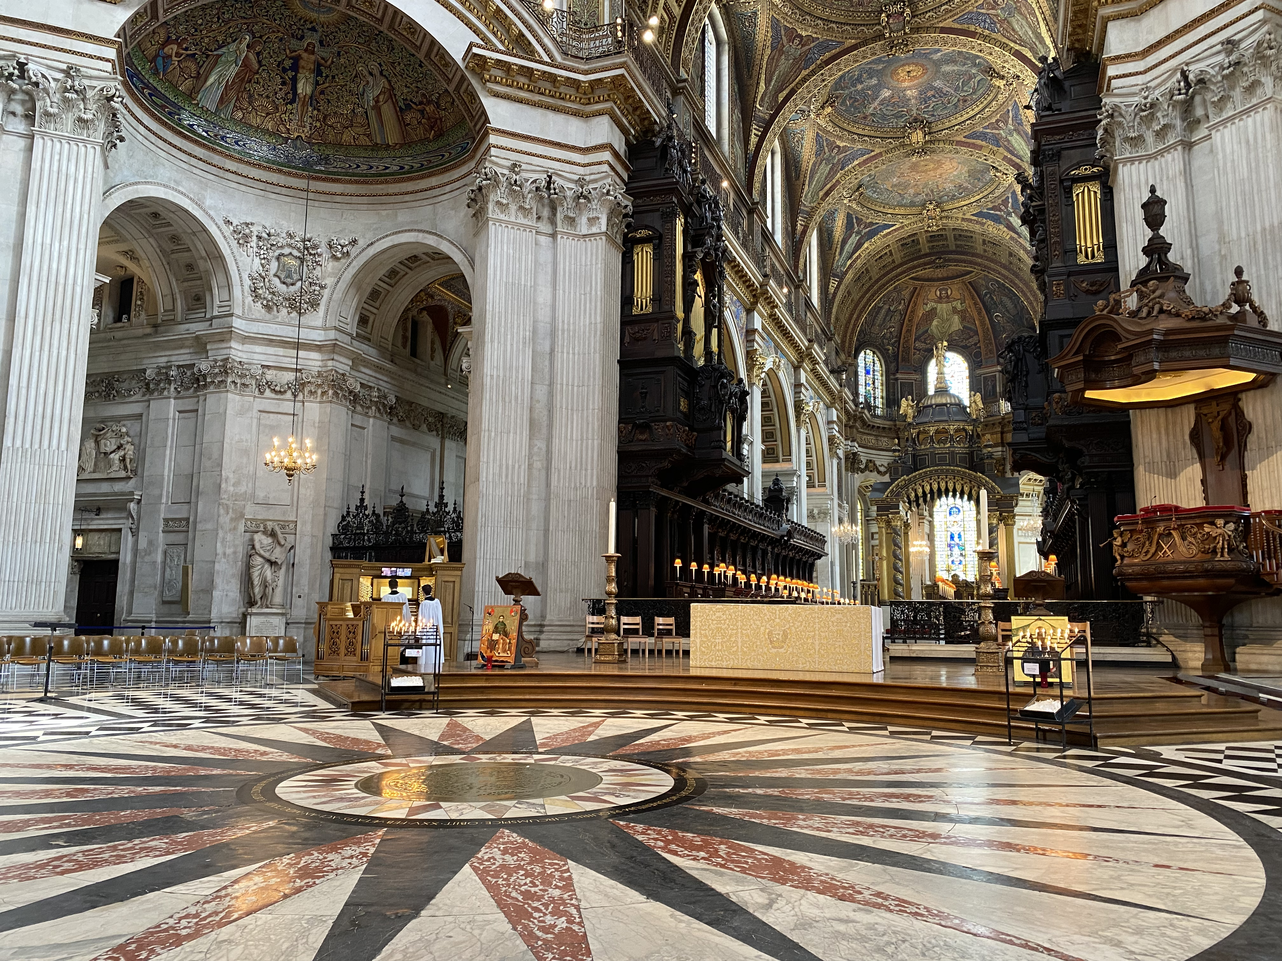

Sam Wells, “Prepare Six Envelops,” Sermon for the Sixth Sunday after Trinity, St. Martin in the Fields, London. https://www.stmartin-in-the-fields.org/the-sixth-sunday-after-trinity-2/
Some of the video interviews can be found on my YouTube Channel at the following link: https://www.youtube.com/channel/UCL00mAwrCGuGuRtZ2fbK0XQ
Rowan Williams, On Augustine (NY: Bloomsbury, 2016).
Interview with Richard Peers, Subdean of Christ Church Cathedral Oxford, Friday 15 July 2022. https://youtu.be/PqIAJ_3SA6I
The inscriptions from St. Paul’s Cathedral, London: “IN PIOUS MEMORY OF HENRY HART MILLMAN, D.D. FOR 19 YEARS DEAN OF THIS CATHEDRAL CHURCH. AUTHOR OF THE HISTORY OF THE JEWS. OF CHRISTIANITY TO THE ABOLITION OF PAGANISM AND OF LATIN CHRISTIANITY. BORN FEB. 10, 1791. DIED SEPT. 24, 1868.” “IN PIOUS MEMOR OF MARY ANNE THE BELOVED WIFE OF HENRY HART MILLMAN SOMETIME DEAN OF THIS CATHEDRAL CHURCH. BENEATH THIS STONE REST IN ONE GRAVE WITH HIM FOR WHOM SHE MADE THE POETRY OF LIFE REALITY. BORN MARCH 17, 1804. DIED JULY 1, 1871 AGED 87 YEARS.”

