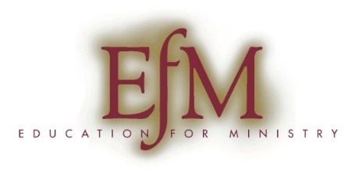

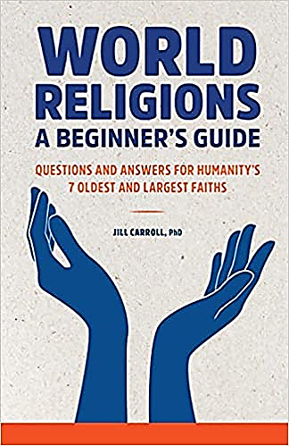
Grace Cathedral Chapter of
Education for (Lay) Ministry
Summer Series 2022
Commonalities: Christianity and other faith traditions
Thursdays 6:15pm – 9:00pm
July 14th, 21st, 28th, and August 4th, 11th, and 18th
The 2022 EfM Summer Series will be using the book World Religions: A Beginner’s Guide by Dr. Jill Carroll to explore the ways our Christian faith and beliefs intersect with other faith traditions around the world.

The series serves as an introduction to the academic year EfM program, as well as a standalone seminar. The reading for each week is generally around 40 pages. Join us if the topic interests you, even if you have no interest in the academic year program.

For more information and registration for the summer series, contact Roberta Sautter, nixile@earthlink.net. There is no tuition except for the cost of the book.

The Academic Year Program
EfM at Grace Cathedral is a small-group (six to twelve) program for lay people in practical theology and group spiritual formation grounded in five core elements:
- Weekly seminar meetings September to June
- Regular Prayer and Worship
- Theological Reflection
- Study of the Christian Tradition (the Bible and church history)
- Vocational Discernment

EfM will change the way you see your church, your community, your spiritual self, and your relationship to God.

