Malcolm Clemens Young Isaiah 43:1-7
Grace Cathedral, San Francisco, CA 2C2 Psalm 29
1 Epiphany (Year C) 11:00 a.m. Eucharist Acts 8:14-17
Sunday 9 January 2022 Luke 3:15-17, 21-22

Civil War in America and Ethiopia
“When you pass through the waters, I will be with you… When you walk through fire… the flame shall not consume you” (Isa. 43).

This week for the first time in my life people are asking the question, “is the United States on a path toward civil war?” Were the Capitol riots on January 6, 2021 an insignificant deviation from our tradition of a peaceful transfer of authority, or was this the beginning of a process that will dissolve democracy as we know it?

At the same time in the Tigray region of Ethiopia, the civil war that started in November 2020 and has already killed ten thousand, continues to go on. When our children were age five and seven our family went there on a pilgrimage to meet other Christians.

I have vivid memories of Axum, of St. Mary’s Cathedral built by Emperor Hailie Sellasie. And most of all the stellae, the massive stone pillars carved seven hundred years before the Norman Conquest of England. Friends told us that 225 coronations of kings had taken place there. I’m only the ninth dean of Grace Cathedral. You can imagine the antiquity of that civilization. At one time the Axumite Empire controlled the Persian Gulf and had distant colonies in Southern Arabia. Ethiopia and Seba are mentioned in our Isaiah reading this morning. Isaiah prophesied from 742 to 701 BCE.

Closing my eyes I can see our small children with their notebooks drawing copies of icons like on the cover or today’s bulletin. I can still imagine wedding parties, the setting sun in the shivering red light at the site of the Queen of Seba’s palace. This is truly a settled country. Flying over the landscape we saw hundreds of threshing circles. Even from our flight we could see the wind direction from the chaff as it flew.

On the most remote mesa in the Simian mountains I saw a tiny remote village hours from any neighbors. At that time 10-15 million people, 30 million in a bad year, depended on some form of food aid. Water is scarce. With global climate change the situation is getting worse.

We humans are all different from each other. We come in different sizes, personalities and nationalities. We were born in different eras, some of us in huge cities and others in remote places. Some of us were nurtured and encouraged and loved. Others were thwarted and neglected. Some of us live emmeshed in the conflict of war, some of us have been relatively protected.

But on the inside we are the same. God moves us by our desire. God speaks to our longing for what is good. God calls us into a deeper experience of holiness, unity and peace. And this is what baptism is fundamentally about: our hunger for God, the habits and fears which keep us at a distance, and finally our ongoing reunion with the one who made us.

Christian tradition on the first Sunday of Epiphany directs us to three stories. Jesus’ baptism in the Jordan by John the Baptist, the journey of the Magii who bring their symbolic gifts to the newborn Jesus and the story of Jesus turning water into wine at a wedding in Cana of Galilee.

Whether you are a new parent or a faithful person with a lifetime of Sundays behind you, I want to make just three observations concerning the baptism of Jesus.

1. Humility. Twenty-first century biblical scholars point out that the most remarkable thing about the baptism of Jesus is that it happened at all. The first thing that Luke writes about John, that compelling prophet in the wilderness, is that he was, “proclaiming a baptism of repentance for the forgiveness of sins” (Lk. 3). Many scholars believe that something like a baptism ritual existed for gentiles who wanted to become Jews.

John used this ritual for everyone who needed metanoia, the Greek word for repentance, but more accurately thought of as a change of heart or life. The tradition teaches us that Jesus was the one person in history who was so focused on God’s mission that he didn’t need this. And yet in solidarity and humility he was baptized just as the rest of us are.

This led to questions that biblical authors tried to answer. It embarrassed the earliest Christians and perhaps followers of Jesus in every generation since then. The point for you and me is the importance of humility. Contemporary society doesn’t seem to value humility. But for many theologians humility was the most important Christian virtue.

Humility does not at all mean being dishonest about your value or contribution. It is not a false modesty or getting attention by saying negative things about yourself. Humility quite simply means putting other people in your life first – not only in your actions but in the way you think about them. It means recognizing that you don’t control everything so that you can be free of your own ego and let God be your god

This is part of what makes parenthood such a holy activity. God gives you this miraculous, demanding child. And you have the sacred responsibility of caring for this baby so that it can grow up in an environment of love and discipline, and grow into a responsible being.

2. Purification. A month ago I talked about what John means about God burning the chaff with unquenchable fire. Because we are primates we divide ourselves into tribes. It’s easy to read about John separating the wheat and the chaff as if the wheat were the good people like us and the chaff was everyone else.

But having watched farmers in Ethiopia actually separate the wheat and the chaff with the wind I can tell you that this is a metaphor about self-purification. Each grain has its chaff or and its lifegiving wheat or grain. We cannot go closer into the presence of God in just the way we are now. Our anxiety, self-obsession, or willingness to right other people off, the fear which leads us to greedily guard or possessions, these diminish us. We are like that person at the airport carrying so much luggage that he has to decide what to leave behind. The water, wind and fire we experience every time we make our promises in baptism purify us, so that we can be full of joy and light rather than the envy and fear that so often takes hold of us.

3. Beloved. For homework this week I want you to look again at the reading from Isaiah, at Isaiah 43:1-7. Bring home the leaflet or print out the reading. Paste it on your refrigerator, or better yet carry it with you on a slip of paper everywhere you go. Have a look at it when you put your keys in your pocket or as you reach for your cell phone.

In the Bible there is the tradition of the beloved child. You see it in Genesis, the Psalms, and the Prophets. At the baptism of Jesus God says, “You are my child, the Beloved; with you I am well-pleased” (Lk. 3). God says this to all of us.

Shut your eyes and really listen to what Isaiah says, “Do not fear, for I have redeemed you; I have called you by name, you are mine. When you pass through the waters, I will be with you; and through the rivers, they shall not overwhelm you; when you walk through fire you shall not be burned, and the flame shall not consume you. For I am the Lord your God…” (Isa. 43).

I don’t know if I’ve mentioned this to you but when we visited Ethiopia we went to a celebration of Epiphany at a fairground with a hundred thousand people. In the middle of all this our daughter Melia went up and for a time sat on the lap of the Abuna, the Ethiopian pope. As a result she was on all the major television networks and every paper. Everywhere we went for the rest of the time we were there people recognized and adored her.

At a restaurant in Axum the waiter picked her up and carried her back to the kitchen so that all the cooks could see her too. They gave her and her brother presents, like little Ethiopian outfits and t-shirts. This all happened in the places where the civil war rages today. And I think of all those people we met and what they must be going through.

No one knows how or whether the tensions of our own public life will be resolved. No one can predict the future or anticipate the end of the United States. But I believe on the inside we are the same. I believe that God speaks to our longing for what is good. I believe that through baptism the habits and fears that keep us apart from God are giving way to an ongoing reunion with the one who made us.

Be humble, purify your thoughts and life, allow yourself to fully experience God’s unchangeable love for you.

Production Notes:
In the recording include the biblical verse I share at the beginning.

Images:
Ethiopian Icons (perhaps from the bulletin cover).
Choose from among the Ethiopian pictures I send: Stellae, Notebooks, Epiphany Celebration, Ethiopian wedding, the Abuna.

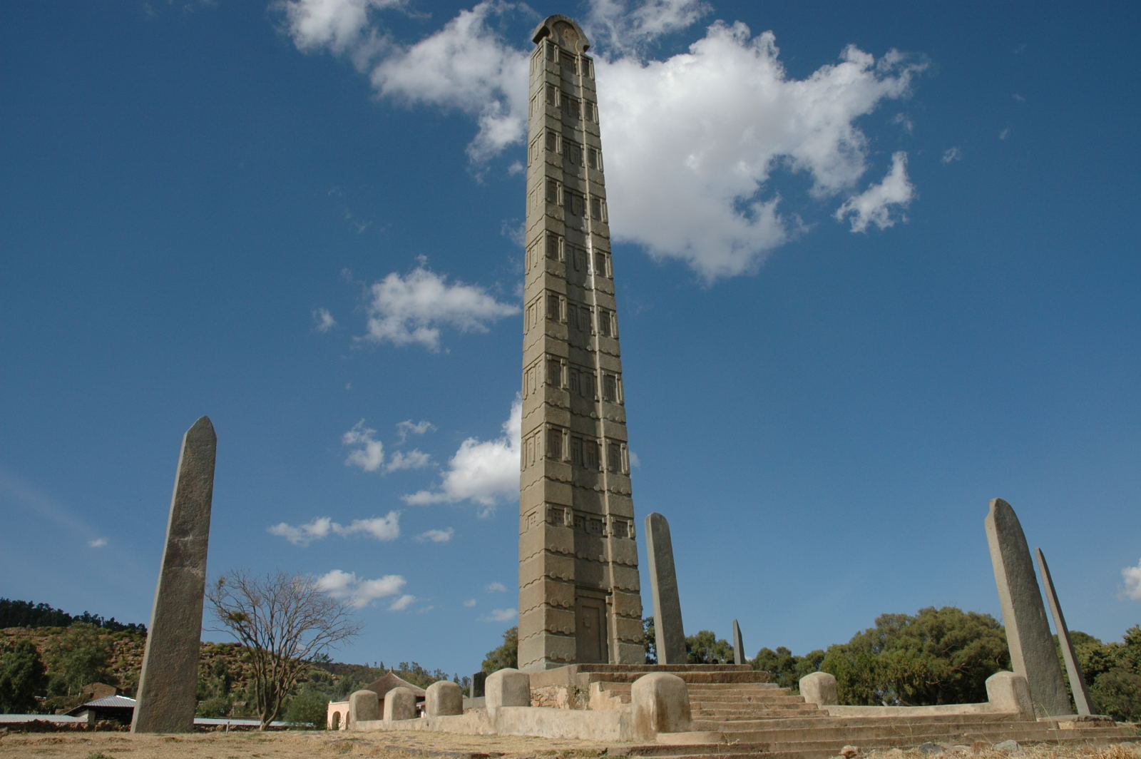
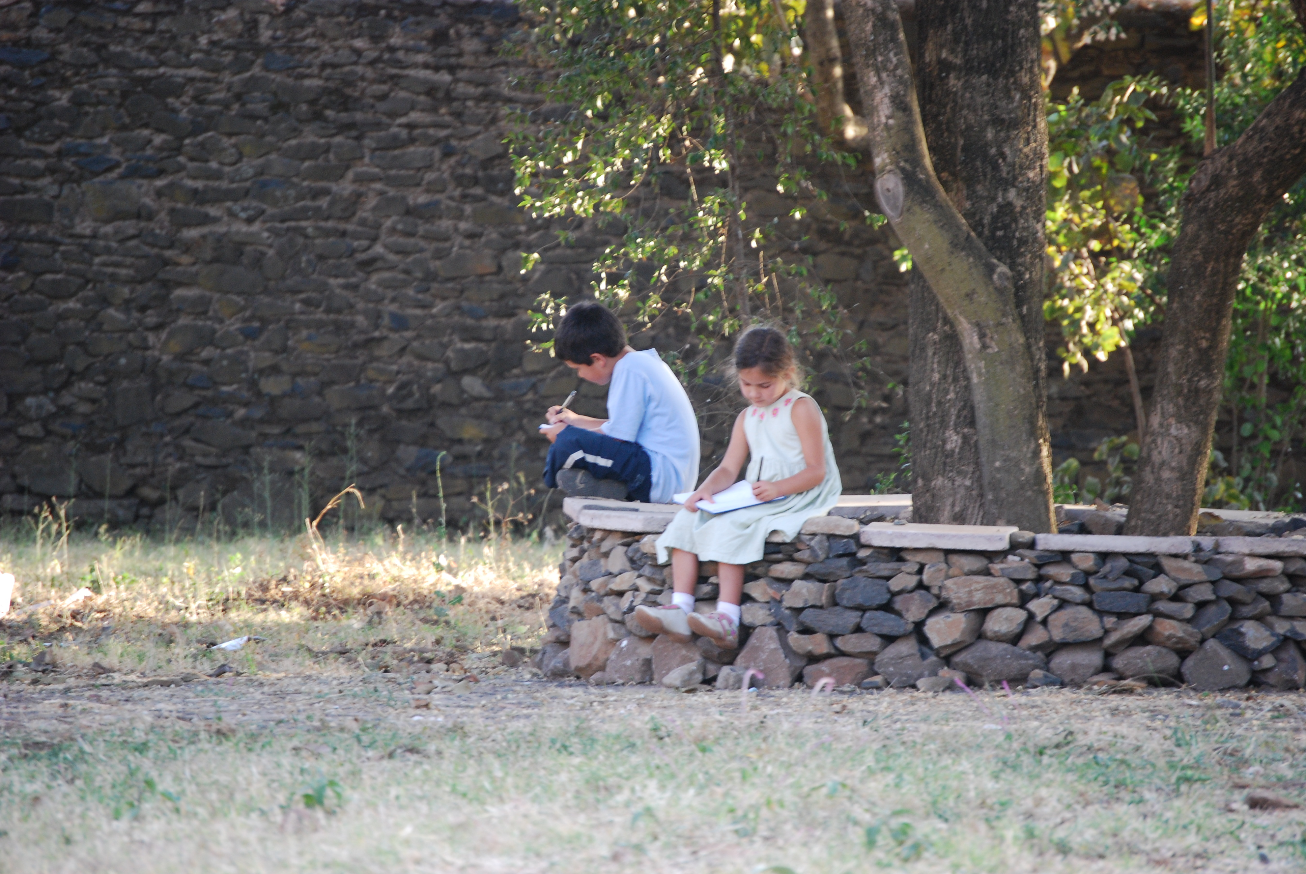
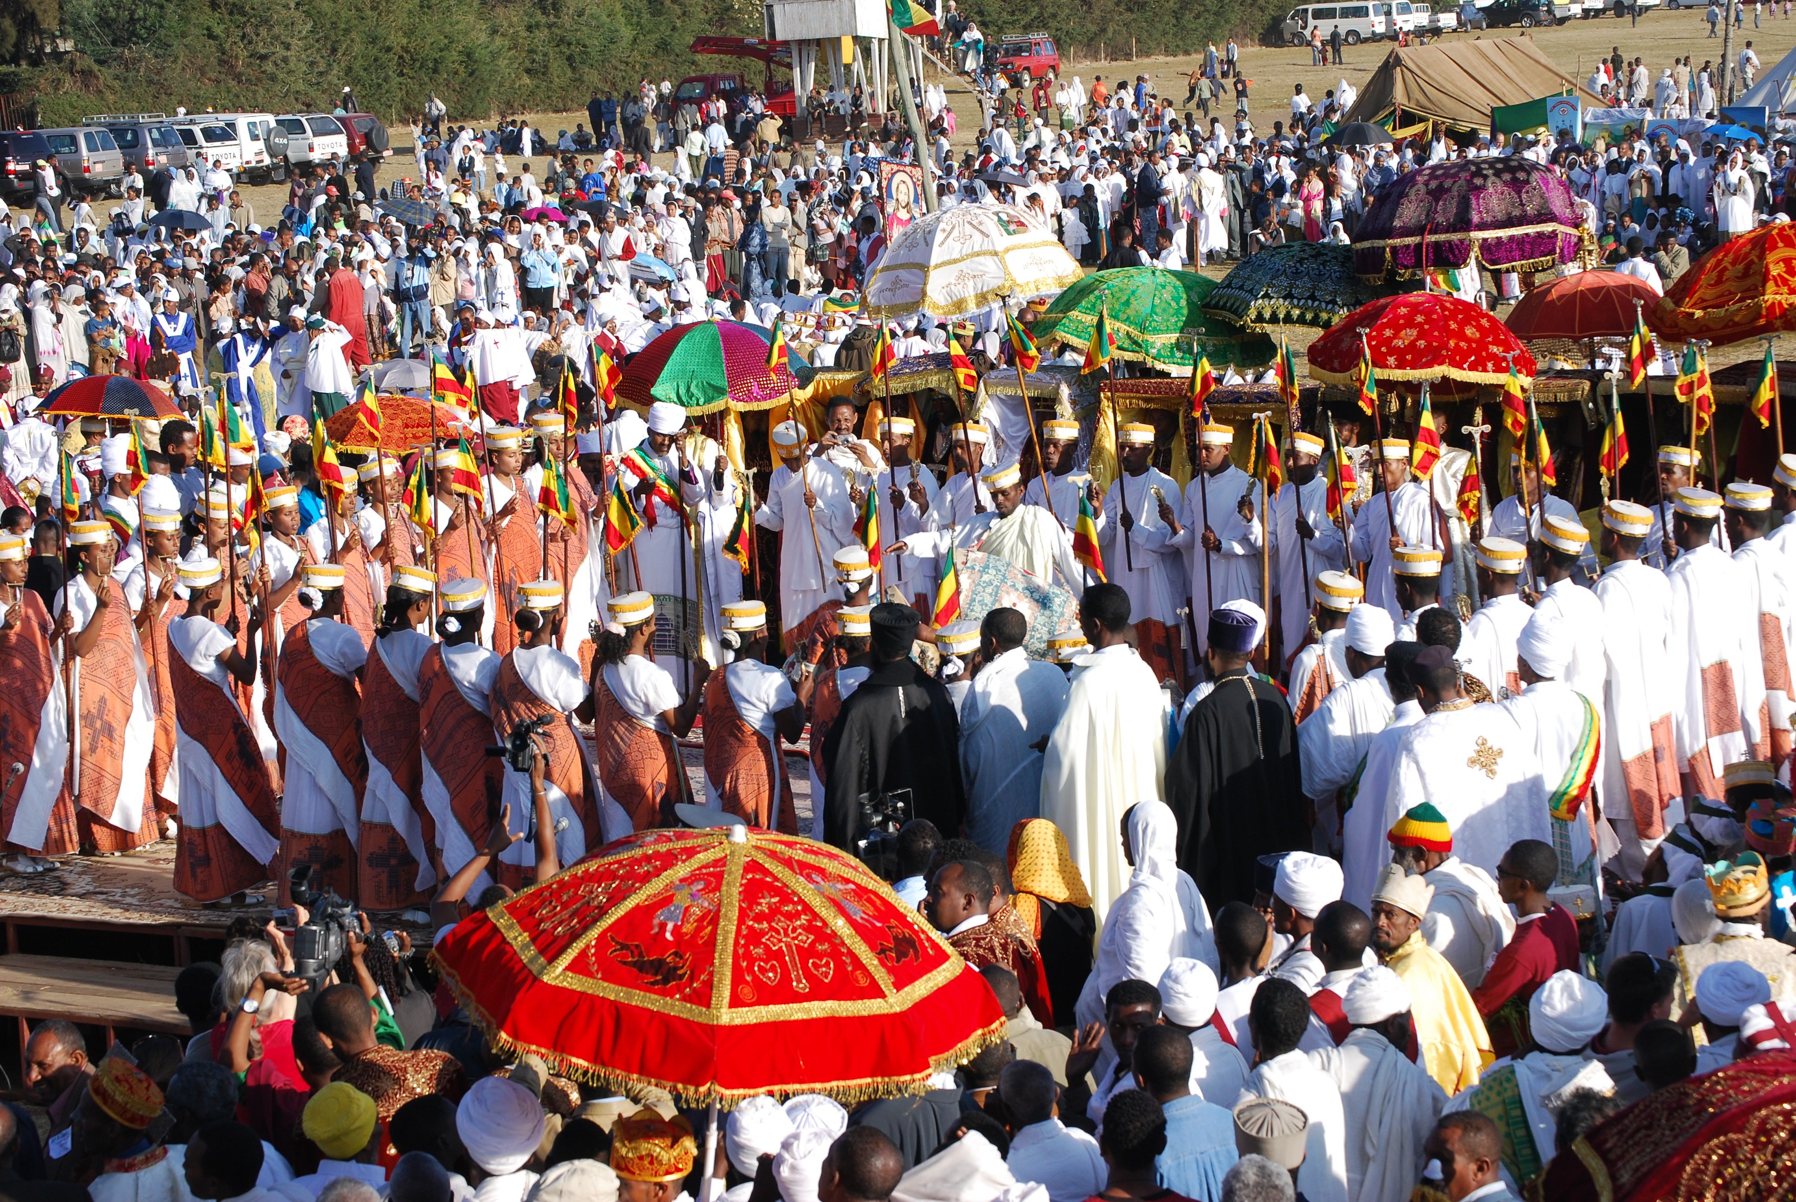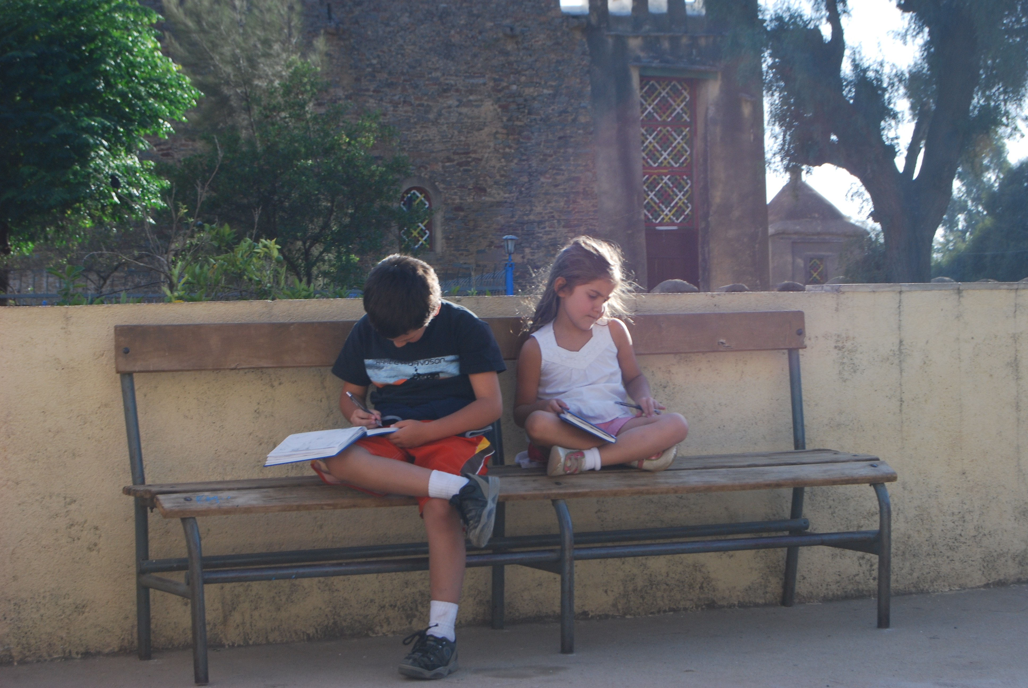

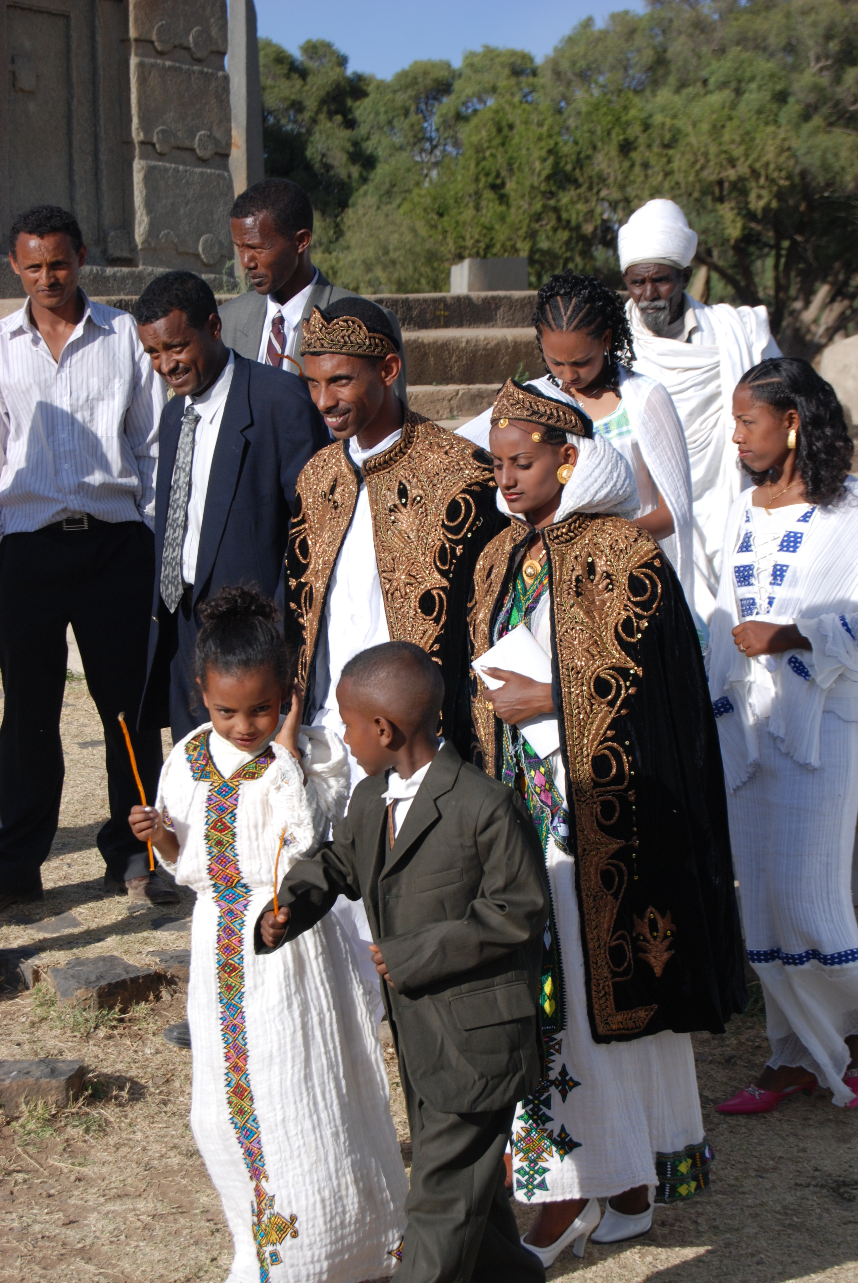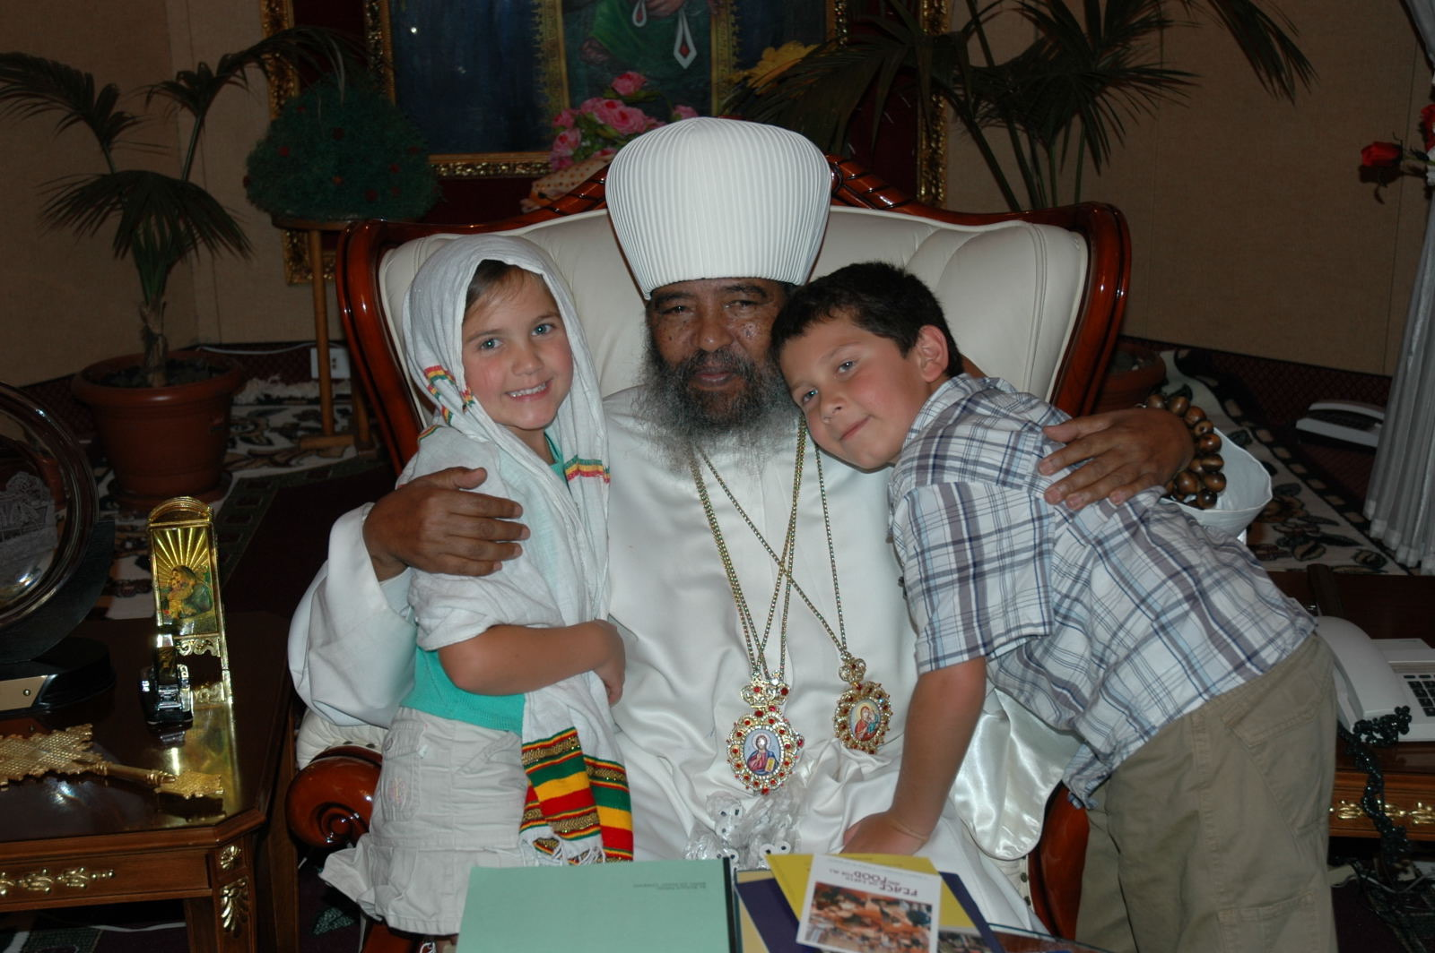
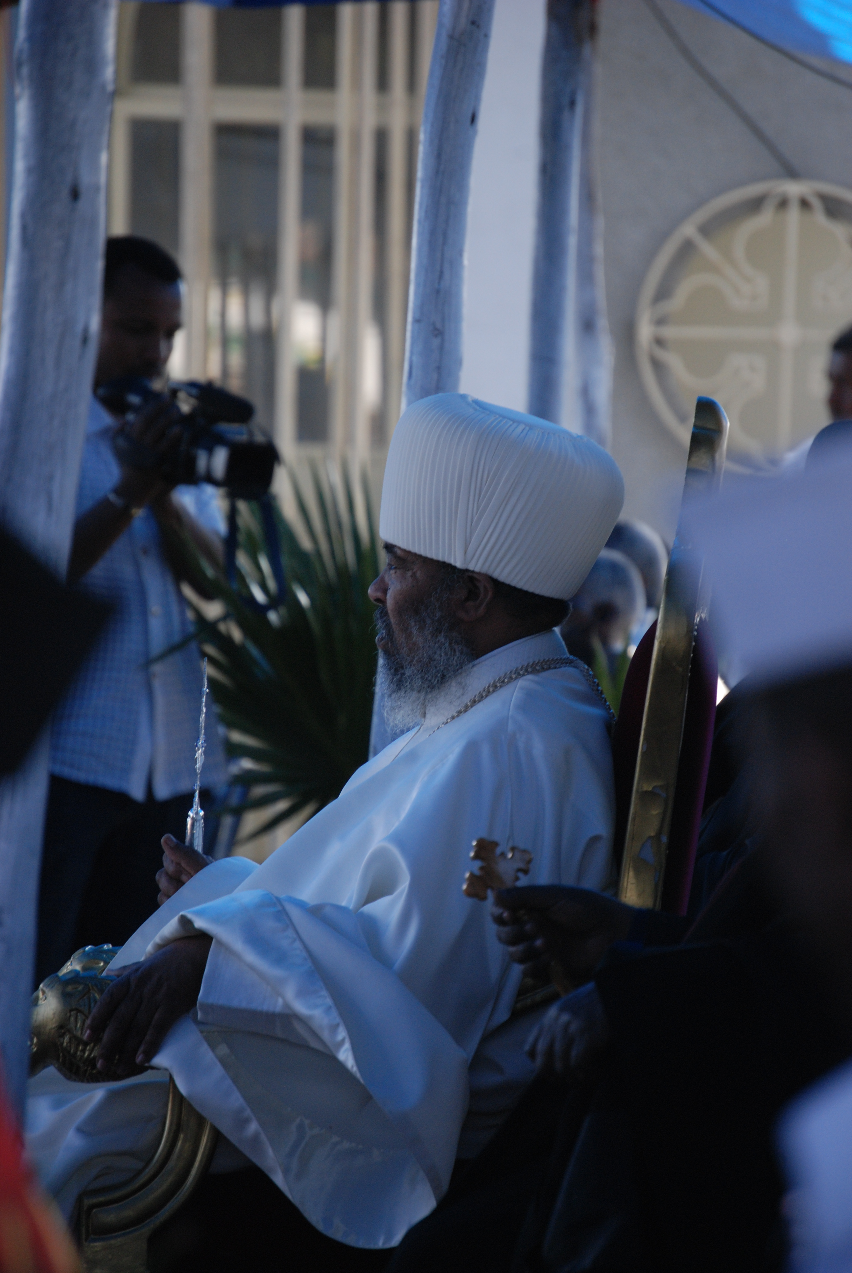

Michelle Goldberg, “Are We Really Facing a Second Civil War?” The New York Times, 6 January 2022. https://www.nytimes.com/2022/01/06/opinion/america-civil-war.html
I preached about this so recently in Advent. I rarely hear about humility outside of church. The threshing image is not about good and bad people, but about the way we need to be purified. Icons that were defaced in the Cathedral, the Chapel wall that was damaged in the atmospheric river, the worn out needlepoints. We are constantly restoring our treasures. Your life is a matter of ongoing art restoration.

